**Agentic AI**

### **Topic:** Multi-File AI Collaboration using Cline

**Introduction:**

Good morning everyone!  
Artificial Intelligence has moved from just giving answers to actually making decisions. This new era is called Agentic AI — where AI systems act like intelligent agents, capable of planning and executing tasks. Today, we’ll explore how tools like Cline make this possible for programmers.  
By the end of this session, you’ll understand how **agentic AI and tools like Cline** are changing the way we program and build intelligent systems.

Installation and workflow:

**Installation:**

1. Open **VS Code**.
2. Go to **Extensions** → search **“Cline”**.
3. Click **Install**.
4. Connect it with an **AI model** (like GPT or Claude).

**Workflow:**

1. **Open your project** in VS Code.
2. **Chat with Cline** to explore or edit code.
3. Cline can **create, modify, explain, or debug** multiple files.
4. **Review and approve** every AI-generated change.
5. Use it to **generate tests, refactor code, and add documentation** easily.
6. It also **tracks your project context**, so AI understands the whole codebase before making changes.

**Conclusion:**  
Cline turns VS Code into a **smart coding partner**, saving time and improving accuracy in every step of development.

**Cline interface look like that:**

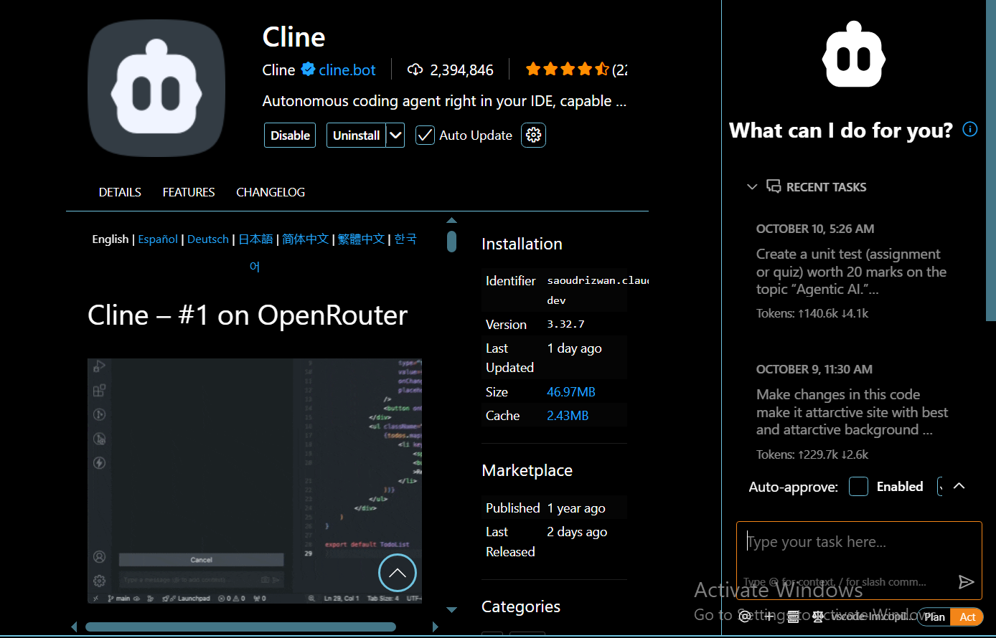

Next we have to just singin with Cline by using our **google account** or using **Github** account.

Now we have successfully connected our VS code with **AI AGENT** cline.

key functions:

• **CLINE Tab** – Switch between normal AI chat and Cline’s project-based coding mode.

• **Recent Tasks** – Shows your past AI commands or code tasks for quick reuse.

• **Auto-approve** – When **Enabled**, lets Cline apply safe code changes automatically.

• **Read / Edit** – Grants AI permission to read or modify your project files.

• **Edit (all), Safe Commands, All Commands, Browser, MCP** – Control what types of actions the AI can perform.

• **Task Input Box** – Type your coding tasks or prompts here to interact with Cline.

• **Model Indicator (bottom left)** – Shows which AI model (e.g., GPT-4) is being used.

• **Settings / Icons (top right)** – Access configuration, account, and help option.

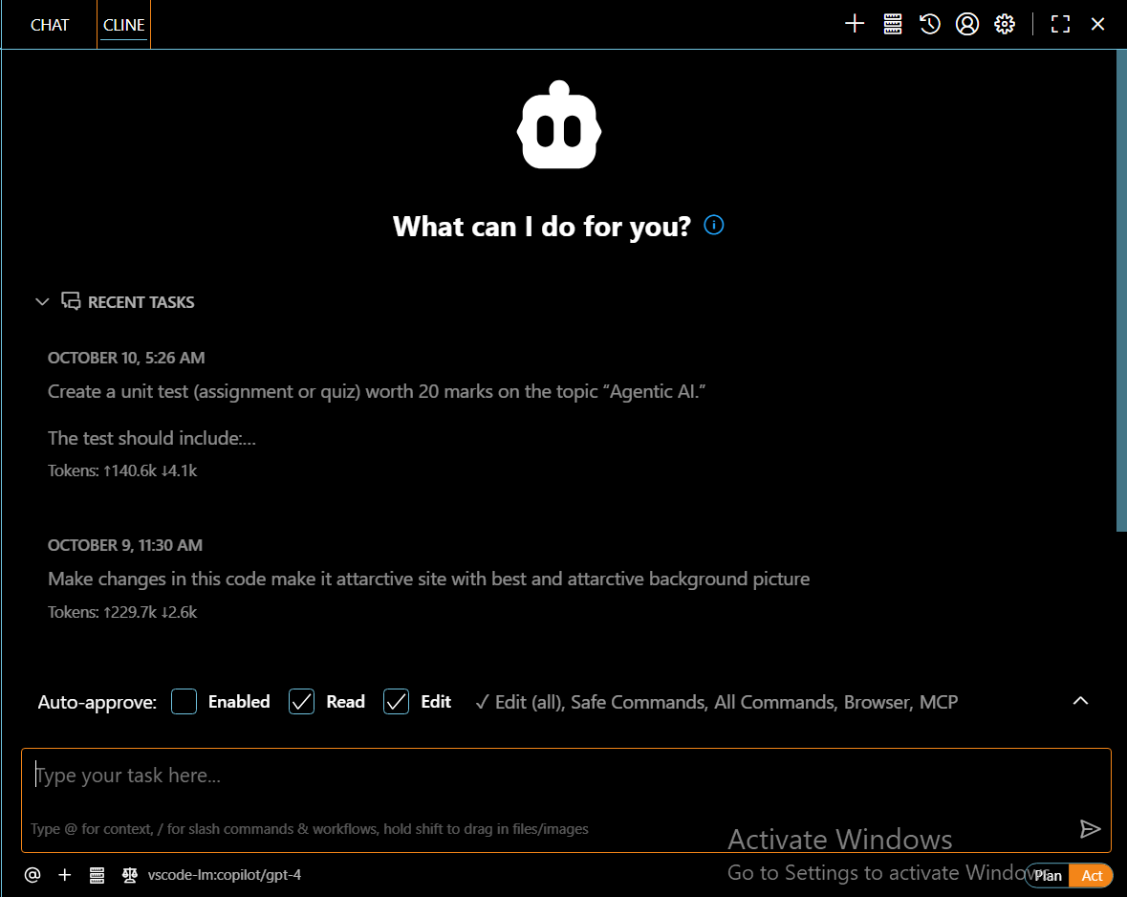

ACT/Plan Mode:

• **Plan Mode:** Cline first **analyzes your request**, explains what steps it will take, and waits for your **approval** before making changes.

• **Act Mode:** Cline **directly performs tasks automatically** (like editing files or running commands) without asking for confirmation.

API Models:

• **API Providers:** Platforms like **OpenAI**, **Anthropic**, or **OpenRouter** that give access to powerful AI models used by tools such as Cline.

• **API Keys:** Unique security codes that **connect your tool to the provider’s server**, allowing safe communication and usage tracking.

• **Functionality:** They let your app or tool **send requests to the AI model**, **get responses**, and **use advanced features** like coding help, reasoning, or image handling — all through a secure and authorized link.

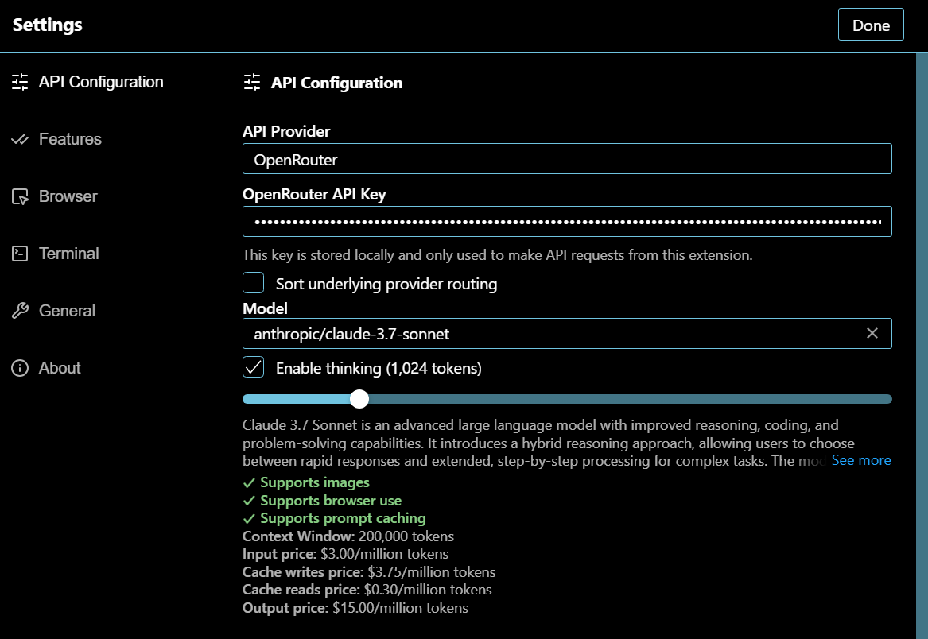

Free API keys Provider Platforms:

• **OpenAI** — New accounts often get small free credits to try the API; sign up and copy the key from your dashboard. [AI Free API](https://aifreeapi.com/en/posts/openai-api-key-free-2025?utm_source=chatgpt.com)

• **Hugging Face (Inference / Hub)** — Free Hub account + limited free inference access for models and Spaces; get key from your profile/settings. [Hugging Face](https://huggingface.co/pricing?utm_source=chatgpt.com)

• **OpenRouter** — Acts as a unified gateway to many models and has developer/demo access tiers; create an account and grab the API key. [OpenRouter](https://openrouter.ai/?utm_source=chatgpt.com)

• **Cohere** — Provides a free trial API key for developers to test models; register and use the trial key from the console. [Cohere](https://cohere.com/pricing?utm_source=chatgpt.com)

• **Replicate** — “Try for free” playground and per-model free/demo usage on signup; obtain the API token in your account. [Replicate](https://replicate.com/pricing?utm_source=chatgpt.com)

• **DeepAI / other small providers** — Offer limited free access for basic endpoints (image/text); sign up to get an API key.

Prompt for Cline:

“Build a responsive and attractive website about core concepts of mathematics and their real-world applications in IT. The home page should have a mathematical formulas background image, short sections on key math topics, and how they are used in programming, AI, data science, and cybersecurity. Use modern UI, smooth navigation, and make it user-friendly and visually appealing.

Integrating documentation or test generation via Cline

Cline can automatically **create documentation or tests** for your code by analyzing functions, classes, and logic — saving time and improving accuracy.

**Prompt Example (for test generation):**  
“Generate unit tests for this Python project using **pytest**, covering all main functions and edge cases.”

**Comparing Cline vs. Copilot (scope, control, depth)**

• **Scope:**

* *Cline* works across the **entire project**, reading and editing multiple files.
* *Copilot* focuses mainly on **single-file code suggestions**.

• **Control:**

* *Cline* lets you **review and approve** every AI change before applying.
* *Copilot* applies suggestions **instantly as you type**.

• **Depth:**

* *Cline* performs **complex reasoning and project-wide refactoring**.
* *Copilot* gives **quick code completions** and short hints

Advantages and disadvantages:

**Advantages:**

* Handles **whole-project reasoning**.
* Allows **review before applying changes**.
* Supports **multi-file edits, tests, and docs**.
* Works with **various AI models** via API.

**Disadvantages:**

* Needs **internet and API setup**.
* Can be **slower** for large projects.
* **Limited offline use**.
* **May make minor coding errors**, requiring review.

**Summary**

So, to wrap up — today we learned how **Agent-Based and Agentic AI Programming** helps create systems that can **think, decide, and act on their own**.  
We explored **Cline**, a smart AI tool inside **VS Code** that helps developers **write, test, and edit code** with the support of intelligent agents.  
You saw how to **install and use Cline**, its **Plan and Act modes**, and how it connects with **API providers and keys** to access powerful AI models.  
We also discussed how Cline can **generate documentation, create tests, and manage full projects**, giving us more control than tools like **GitHub Copilot**.  
In short, Cline makes coding **smarter, faster, and more interactive**, showing how AI and programming are now working hand in hand.

**Closing Line:**  
I hope this session helped you understand how **Agentic AI and tools like Cline** are shaping the future of programming and automation. Thank you!

ALLAH HAFIZ⚔